1. List the characteristics of Manet

* **Dynamic Topologies:**   
  Network topology which is typically multihop may change randomly and rapidly with time, it can form unidirectional or bi-directional links.
* **Bandwidth constrained, variable capacity links:**   
  Wireless links usually have lower reliability, efficiency, stability, and capacity as compared to a wired network
* **Autonomous Behavior:**   
  Each node can act as a host and router, which shows its autonomous behavior.
* **Energy Constrained Operation:**   
  As nodes rely on batteries or other exhaustible means for their energy. Mobile nodes are characterized by less memory, power, and lightweight features.
* **Limited Security:**   
  Wireless networks are more prone to security threats. A centralized firewall is absent due to the distributed nature of the operation for security, routing, and host configuration.
* **Less Human Intervention:**   
  They require minimum human intervention to configure the network, therefore they are dynamically autonomous in nature.

1. Define the term dynamic topology

Network topology which is typically multi hop may change randomly and rapidly with time, it can form unidirectional or bi-directional links.

1. Explain the meaning of "every node is autonomous"

Each node can act as a host and router, which shows its autonomous behavior.

1. What do you understand by self-configuring n self-healing nodes
2. List pros n cons of Manets

|  |  |
| --- | --- |
| Pros | Cons |
| * Separation from central network administration. * Each node can play both the roles ie. of router and host showing autonomous nature. * Self-configuring and self-healing nodes do not require human intervention. * Highly scalable and suits the expansion of more network hub. | * Resources are limited due to various constraints like noise, interference conditions, etc. * Lack of authorization facilities. * More prone to attacks due to limited physical security. * High latency i.e. There is a huge delay in the transfer of data between two sleeping nodes. |

1. What is manet and list the types of Manets

* **Vehicular Ad hoc Network (VANETs) –**   
  Enable effective communication with another vehicle or with the roadside equipments. Intelligent vehicular ad hoc networks(InVANETs) deals with another vehicle or with roadside equipments.
* **Smart Phone Ad hoc Network (SPANC) –**   
  To create peer-to-peer networks without relying on cellular carrier networks, wireless access points, or traditional network infrastructure. Here peers can join or leave the network without destroying it.
* **Internet based Mobile Ad hoc Network (iMANETs) –**   
  It supports internet protocols such as TCP/UDP and IP. To link mobile nodes and establish routes distributed and automatically.
* **Hub-Spoke MANET:**   
  Multiple sub MANET’s may be connected in hub-spoke VPN to create a geographically distributed MANET. Normal Ad-hoc routing algorithm does not apply directly.
* **Military or Tactical MANETs –**   
  This is used by the military units. Emphasis on data rate, real-time demand, fast re-routing during mobility, security, radio range, etc.
* **Flying Ad hoc Network (FANETs) –**   
  This is composed of unmanned aerial vehicles (commonly known as drones). Provides links to remote areas and mobility.

1. What is the concept of routing in Manet

Nodes do not know the topology of their network, instead they must discover it by their own as the topology in the ad-hoc network is dynamic topology.

The basic rules are that a new node whenever enters an ad-hoc network, must announce its arrival and presence, and should also listen to similar announcement broadcasts made by other mobile nodes.

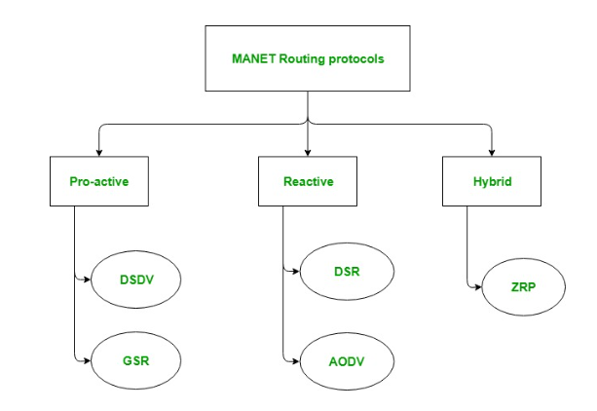

1. Differentiate between proactive n reactive routing protocols in Manet

|  |  |
| --- | --- |
| ProActive | ReActive |
| * These are also known as table-driven routing protocols. Each mobile node maintains a separate routing table which contains the information of the routes to all the possible destination mobile nodes. * Since the topology in the mobile ad-hoc network is dynamic, these routing tables are updated periodically as and when the network topology changes. * It has a limitation that it doesn’t work well for the large networks as the entries in the routing table becomes too large since they need to maintain the route information to all possible nodes. | * These are also known as on-demand routing protocol. In this type of routing, the route is discovered only when it is required/needed. * The process of route discovery occurs by flooding the route request packets throughout the mobile network. * It consists of two major phases namely, route discovery and route maintenance. |

1. Explain DSDV Protocol with example

DSDV protocol uses and maintains a single table only, for every node individually. The table contains the following attributes.

Routing Table : It contains the distance of a node from all the neighboring nodes along with the sequence number( SEQ No means the time at which table is updated).

This image describes the header format of Destination Sequenced Distance Vector Routing protocol

Destination Sequenced Distance Vector Routing : Format

This table is updated on every step and ensures that each node broadcast as well as receives correct information about all the nodes including their distance and sequence number.

In DSDV, nodes broadcasts their routing tables to immediate neighbors with the sequence number.

Every time any broadcasting occurs, the sequence number is also updated along with distances of nodes.

* Consider a network of 3 nodes having distances of “1” on each of the edges respectively. Below mentioned steps will let you know how DSDV works and routing tables are updated.

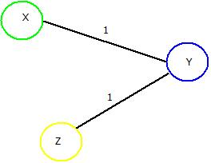

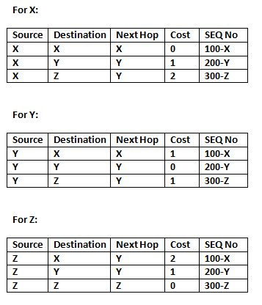

**If “Y” wants to broadcast the routing table. Then updated routing tables of all the nodes in the network will look like as depicted in the below tables where red marked cell denotes the change in sequence number.**

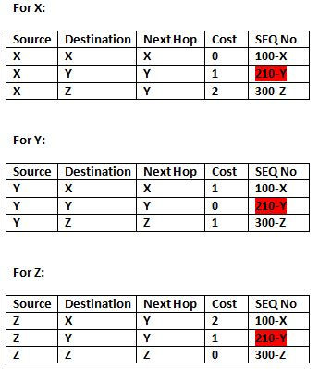

1. Highlight how count to infinity problem be solved using DSDV
2. Explain the working of GSR protocol along with example and format of all tables

* GSR protocol uses and maintains three tables for every node individually. These tables are:

1. Distance Table : This table contains the distance of a node from all the nodes in network.

2. Topology Table : This table contains the information of Link state data along with the sequence number which can be used to determine when the information is updated last.

3. Next Hop Table : Next hop table will contain the information about the immediate neighbor of a particular node.

**These tables are updated on every step and ensures that each node receives correct information about all the nodes including their distances.**

* Consider a network of 4 nodes having a distance of “1” on each of its edge. Below mentioned steps will let you know how GSR works and how its routing tables are updated.

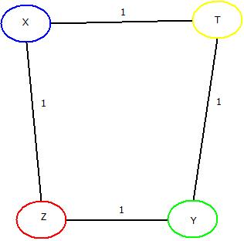

* For Node “X” : Firstly three tables as mentioned above will be maintained which includes distance table, Topology table and Next hop tables. This same process will be done for rest of the nodes too.
* Table

  Description automatically generated Secondly, broadcasting of all the tables will be done to all the immediate neighbors of “X” i.e. “Y” and “Z”.
* These tables are updated at “X”, “Y” & “T” nodes respectively.
* Same will be done for node “Y”. After first updation from “X”, node “Y” will broadcast the tables to its immediate neighbors i.e. “X” & “T” and those tables will be updated accordingly. This will be done for “T” & “Z” also.
* Once done, all the nodes “X”, “Y”, “Z” & “T” will be having the updated routing tables containing distances from each, with the help of which an optimal path can be chosen if data needs to be transferred from one node to other.
* 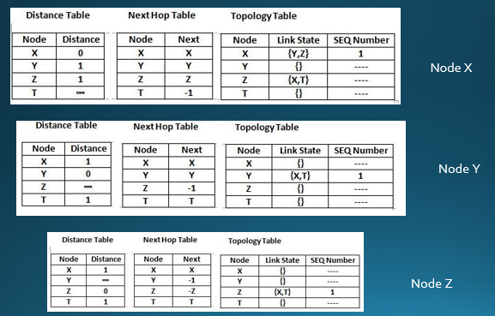 **Now, broadcasting of topology tables of “X” will take place to its neighbour i.e. “Y” & “Z” and updated tables will be like as mentioned below.**

**Similarly, these tables are further updated with topology tables of “Y”, “Z” & “T” as done in case of “X.**

1. Explain the process of identifying an optimal path in dynamic source routing with an example

* Step 1: Start from source node N1 and broadcast the information about it to its neighbors i.e. in this case the route information is “<1>”, because of its one-to-one link between node N1 and N2.
* Step 2: Broadcast previous route information to neighbors of node N2 i.e. to node N3, N4, N5. The new route will remain same “<1,2>” in all the cases.
* Step 3: Take node N3 and broadcast previous route(<1,2>) to next neighboring nodes i.e. node N6. New route till node N6 will be “<1,2,3>” and same process can be done for other nodes i.e. Node N4 and N5.
* Step 4 : Further, broadcast the new routes i.e. <1,2,3,6> , <1,2,4> , <1,2,5> to nodes N8, N7 & N9 respectively.
* Step 5: Repeat the above steps until destination node is reached via all the routes.

The updated routes will be as:

* After this, “Re-Request” packet will be sent in backward direction i.e. from destination node “N10” to source node “N1”. It will trace the shortest route by counting the number of nodes from route discovered in previous steps.
* The three possible routes are :
* Route 1: <1,2,3,6,8>
* Route 2: <1,2,4,7,8>
* Route 3: <1,2,5,9>
* Route 3 i.e. "<1,2,5,9>” will be chosen as it contains the least number of nodes and hence it will definitely be the shortest path and then data can be transferred accordingly.
* The Re-Request Packet route can be located as:

1. Explain the working of AODV protocol

* In Ad-Hoc On Demand Distance Vector Routing, the source node and destination nodes IP addresses are already known.
* The goal is to identify, discover and maintain the optimal route between source and destination node in order to send/receive data packets and informative.
* Each node comprises of a routing table along with below mentioned format of Route Request(RREQ) packet.
* RREQ { Destination IP, Destination Sequence Number, Source IP, Source Sequence Number, Hop Count}
* Consider a network containing 5 nodes that are “X”, “Y”, “Z”,”T”,”D” present at unit distance from each other, where “X” being the source node and “D” being the destination node.
* **The IP addresses of source node “X” and destination node “D” is already known. Below mentioned steps will let you know how AODV works and concept of Route Request(REREQ) and Route Response(RRESP) is used.**
* **Step 1: Source node “X” will send Route Request i.e. RREQ packet to its neighbours “Y” and “Z”.**
* **Step 2: Node “Y” & “Z” will check for route and will respond using RRESP packet back to source “X”. Here in this case “Z” is the last node but the destination. It will send the RREQ packet to “X” stating “Route Not Found”. But node “Y” will send RRESP packet stating “Route Found” and it will further broadcast the RRESP to node “T”.**
* **Step 3: Now the field of net hop in the RREQ format will be updated, Node “T” will send back the “Route Found” message to Node “Y” and will update the next hop field further.**
* **Step 4: Then Node “T” will broadcast and RREQ packet to Node “D”, which is the destination and the next hop field is further updated. Then it will send RRES packet to “T” which will further be sent back to the source node “X” via node “Y” and Node “T” resulting in generation of an optimal path. The updated network would be:**

MIMO

1. Explain the concept of beam forming in MIMO

[Beamforming](https://www.techtarget.com/searchnetworking/definition/beamforming) is an RF management technique that maximizes the signal power at the receiver by focusing broadcast data to specific users instead of a large area. With 5G, three-dimensional (3D) beamforming forms and directs vertical and horizontal beams at the user. These can reach devices even if they're at the top of a high-rise, for example. The beams prevent interference with other wireless signals and stay with users as they move throughout a given area.

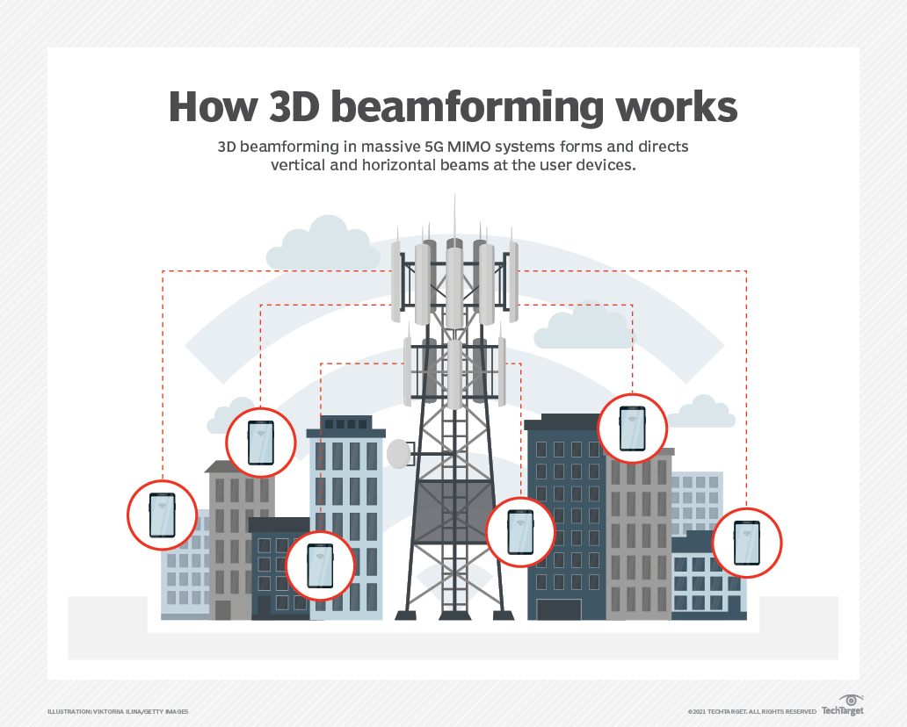

1. What is the advantage of MIMO technology

* MIMO enables stronger signals. It bounces and reflects signals so a user device doesn't need to be in a clear line of sight.
* Video and other large-scale content can travel over a network in large quantities.
* This content travels more quickly because MIMO supports greater throughput.
* Many data streams improve visual and auditory quality. They also decrease the chance of lost data packets.

1. Differentiate between OFDM and FDM

* OFDM builds on simpler frequency-division multiplexing (FDM).
* In FDM, the total data stream is divided into several subchannels, but the frequencies of the subchannels are spaced farther apart so they do not overlap or interfere.
* With OFDM, the subchannel frequencies are close together and overlapping but are still orthogonal, or separate, in that they are carefully chosen and modulated so that the interference between the subchannels is canceled out.

1. Application of OFDM systems

* Digital radio, Digital Radio Mondiale, and digital audio broadcasting and satellite radio.
* Digital television standards, Digital Video Broadcasting-Terrestrial/Handheld (DVB-T/H), DVB-Cable 2 (DVB-C2). OFDM is not used in the current U.S. digital television Advanced Television Systems Committee standard, but it is used in the future 4K/8K-capable ATSC 3.0 standard.
* Wired data transmission, Asymmetric Digital Subscriber Line (ADSL), Institute of Electrical and Electronics Engineers (IEEE) 1901 powerline networking, cable internet providers. Fiber optic transmission may use either OFDM signals or several distinct frequencies as FDM.
* Wireless LAN (WLAN) data transmission. All Wi-Fi systems use OFDM, including IEEE 802.11a/b/g/n/ac/ax. The addition of OFDMA to the Wi-Fi 6/802.11ax standard enables more devices to use the same base station simultaneously. OFDM is also used in metropolitan area network (MAN) IEEE 802.16 Worldwide Interoperability for Microwave Access (WiMAX>) installations.
* Cellular data. Long-Term Evolution (LTE) and 4G cellphone networks use OFDM. It is also an integral part of 5G NR cellular deployments.

1. Define the term MIMO and Diversity gain in MIMO

# MIMO

Multiple-Input Multiple-Output (MIMO) is **a wireless technology that uses multiple transmitters and receivers to transfer more data at the same time**.

All wireless products with 802.11n support MIMO. The technology helps allow 802.11n to reach higher speeds than products without 802.11n.

an antenna technology for wireless communications in which multiple antennas are used at both the source (transmitter) and the destination (receiver).

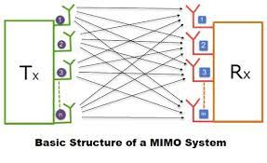

# Diversity Gain

* Diversity gain is **the decreased required receive SNR for a given bit error rate (BER) averaged over the fading**.
* This is the reduction in fading margin that's obtained by reducing the fading with the smart antenna.